


ENGINEERING DRAWING
(ME-109)
DE-47 Mechatronics
Syndicate – B
Submitted to: MA’AM Aleeya Rizwan

- MUHAMMAD AHMAD QAISAR
- MUHAMMAD UMAIR RASHID
- MUHAMMAD AHMAD

“SLIDER CRANK”
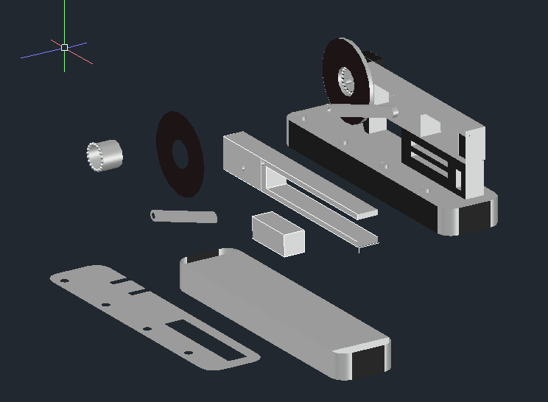
“INTRODUCTION”

- Slider Crank:
After a great discussion within the group, member decided to create a machine, which was the core mechanism for various useful devices.Therefore, the group ended up selecting slider crank as Engineering drawing project. The device basically is used to convert one type of motion to another using dead centers, ratio and strokes ,and harmonic motions. It constituents of crank disc, connecting rods, piston, piston pins, cylinder , and bearings as key parts.

- Device Function:
Its main functions include converting of rotary motion into linear motion, transferring of force and motion efficiently, producing reciprocating motion , changing speed and torque characteristics ,and controlling stroke length. It has multiple real life applications like:
- IC engines
- Compressors
- Reciprocating pumps
- Mechanical presses
- Old steam engines

“COMPONENT DESCRIPTIONS”
There are total 6 main components:
- Crank Disc
- Connecting rods
- Piston
- Piston Pins
- Cylinder
- Bearing
- Crank Disc:
Crank Disc is the heart of the device. It is disc shaped figure. It is responsible for producing rotation. It provides center of axis. It was created simply by circle command.
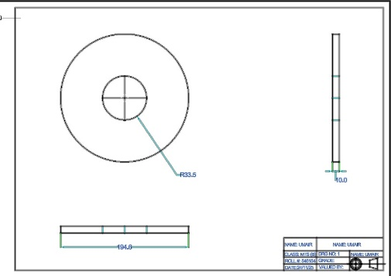
- Connecting Rod:
Connecting rod serves as a link between Crank Disc and Piston. It has long rigid structure, with hole at ends. It makes the conversion of Rotary motion into Linear motion. It was created by circle and line command. By trimming and joining the partes, it was ready. In end hole was made by presspull command.
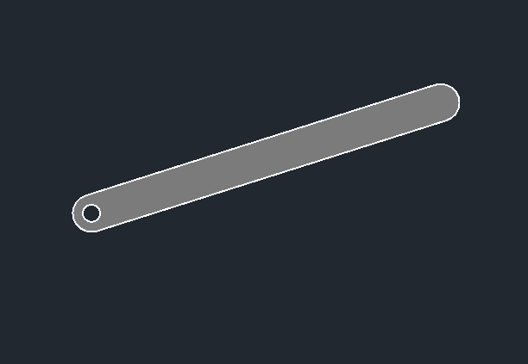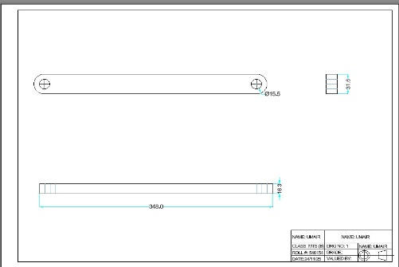
- Piston:
The general aim of the piston is to be the intermediary between the energy and movement. It is a small cylindrical shaped figure, which has pin at end to connect with connecting rod. Rectangle command was used to create the part.
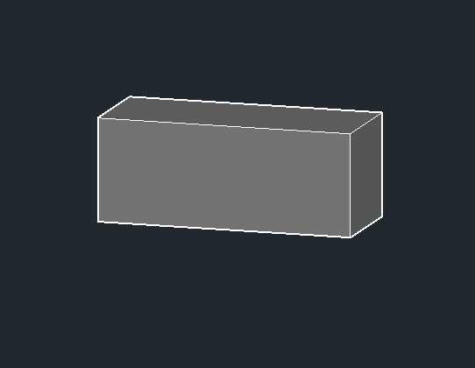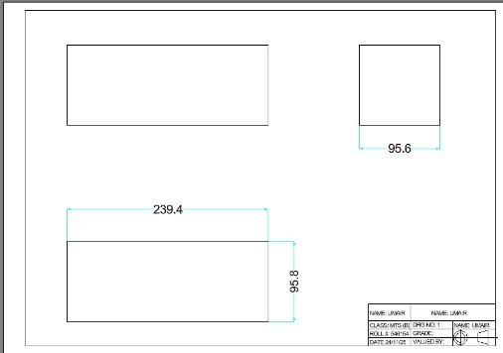

- Piston Pins:
The piston pin with the connecting rod gives motion transfer to the engine provided by the piston. It was produced through the circle and presspull commands.
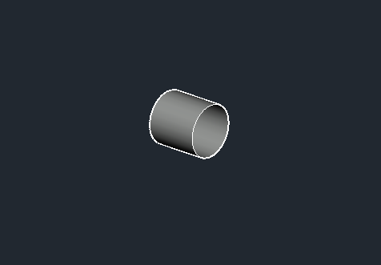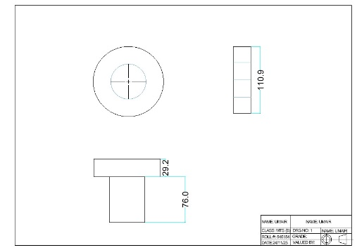
- Cylinder:
The cylinder directs and closes the movement of the piston which is formed by the subtraction of the rectangle and transferred to two parallel parallel tracks.
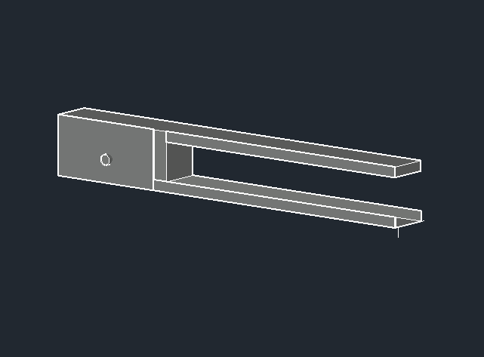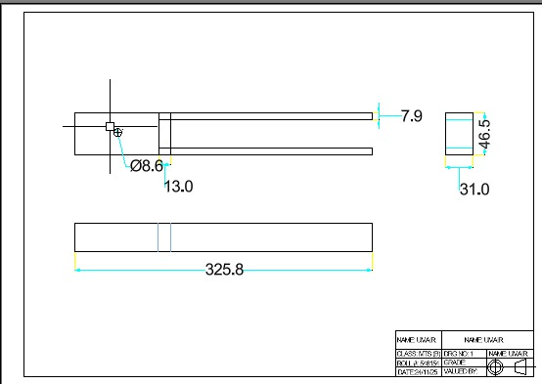
- Bearings:
A bearing is a highly machined product which supports, directs and causes less friction among moving parts. It was created through circle and polar array command.
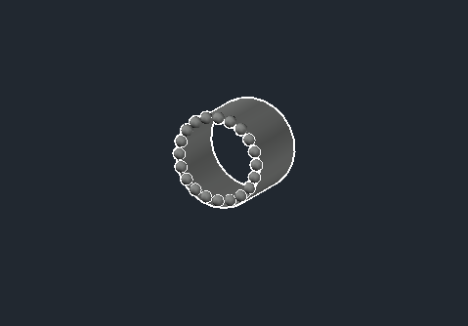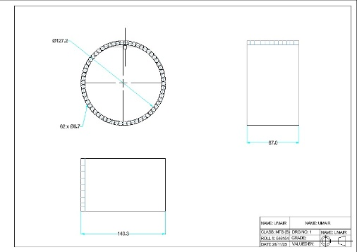

“AutoCAD Implementation”
AutoCAD techniques:
First of all, we created a working environment in autoCAD, required units Annotations, and properties were enabled. In drafting and annotation, we made a base first and by using presspull command, we made components one by one except screws that were formed by enabling UFC. At last, the components were merged to form slider crank. Other than crucial components, we designed a crank and added colors using material command. Exploded view was created to see all components easily. Orthographic views were formed by using flatshot command. And then, modifications were made by adding suitable hidden lines.
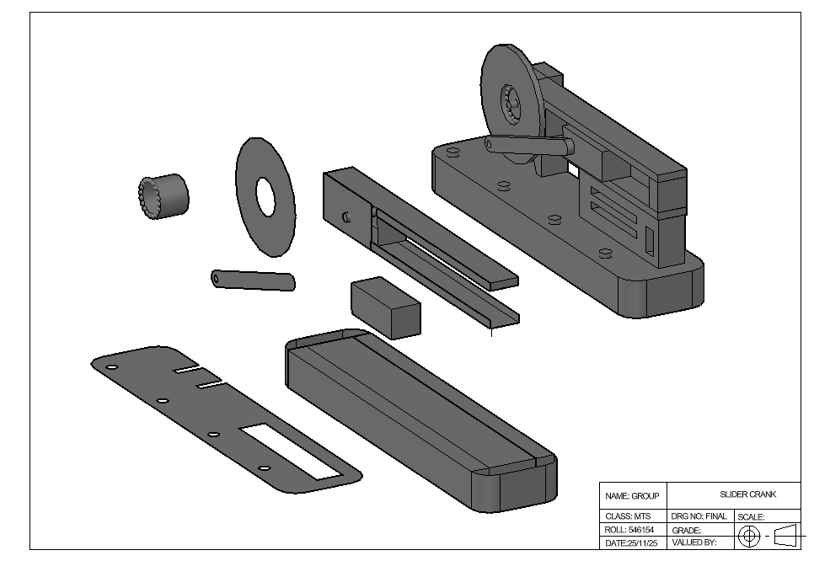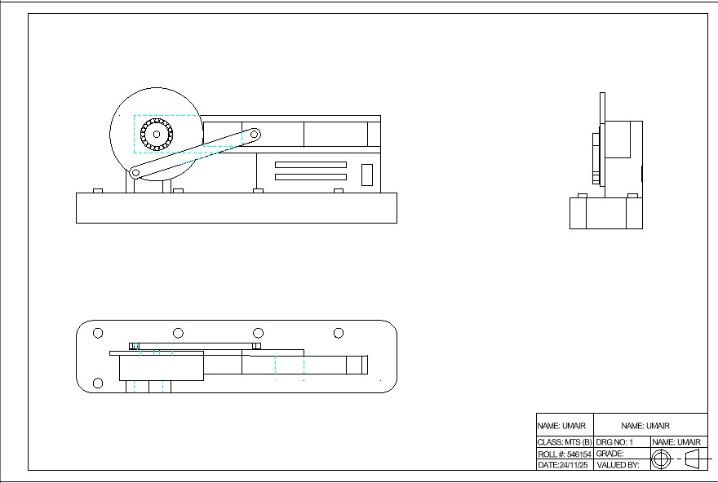
“Conclusion”
- Challenges encountered:
It was very hard to form bearing of slider crank as 3d Polar array was not known. Design selection created mess, as the connecting rod not stuck with cylinder. Every step was well known but really time taking, because involving every participant equally in Autocad task meaningfully was difficult.
Summary:
The selection was based on the contribution of machine in daily tasks. Although it seems to be simple, but things get difficult when it comes to number of parts and assembling. It enabled us to make grip on different commands and efficient working.

